Chapter 11, Solution 55.

Using Fig. 11.74, design a problem to help other students to better understand the conservation of AC power.

Although there are many ways to work this problem, this is an example based on the same kind of problem asked in the third edition.

Problem

Find the complex power absorbed by each of the five elements in the circuit of Fig. 11.74.

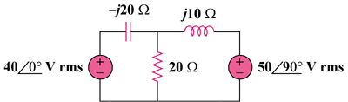

Figure 11.74

Solution

We apply mesh analysis to the following circuit.
5090 V rms
400 V rms
j10 
20 
-j20 
+
−
+
−
I₁
I₂
I₃
For mesh 1,
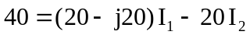
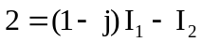 (1)
For mesh 2,
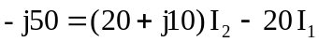
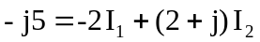 (2)
Putting (1) and (2) in matrix form,
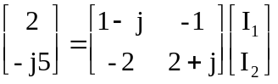

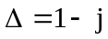, 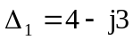, 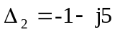

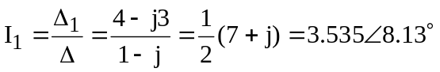
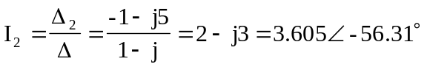
For the 40-V source,
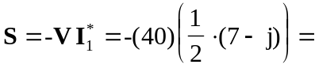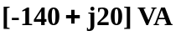
For the capacitor,
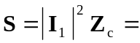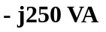
For the resistor,
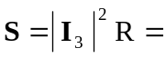
For the inductor,
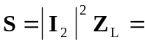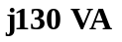
For the j50-V source,
